TITLE:
Insurance Disparities in Liver Transplant Access: Medicaid and Uninsured Face Worse Outcomes
Background: Insurance status is a key social determinant of health and may influence access to liver transplantation. However, prior studies rarely account for competing risks, where transplant precludes waitlist death and vice-versa. We evaluated how insurance type affects waitlist outcomes using a competing-risk approach.
Methods: We analyzed 121,123 adult liver transplant candidates sampled from the UNOS waitlist (2018–2023). Fine-Gray competing risk models were used to estimate subdistribution hazard ratios (sHR) for time to transplant (failcode = 1) and waitlist death (failcode = 2). Private insurance served as the reference. Models were adjusted for age, gender, race/ethnicity, MELD at listing, UNOS region, ABO blood type, and HCC exception status. Cumulative incidence functions (CIF) at 3 years were computed for each insurance group.
Results: Compared with private insurance, Medicaid patients had a significantly lower transplant rate (sHR 0.90, 95% CI 0.83–0.97, p=0.006), and “Other” insurance had an even lower rate (sHR 0.85, 95% CI 0.73–0.99, p=0.041). Medicare patients showed no significant difference (sHR 0.98, p=0.51). For waitlist death, Medicare patients had the highest mortality risk (sHR 1.24, 95% CI 1.03–1.48, p=0.022), followed by Medicaid (sHR 1.15, p=0.16), although the latter did not reach statistical significance in this sample. CIF curves at 3 years showed the following transplant percentages: Private 74%, Medicare 70%, Medicaid 69%, Other 69%. Three-year mortality was highest for Medicare (11.9%), followed by Medicaid (11%) and Private (8.9%).
Conclusions: Insurance type is independently associated with liver transplant access. Patients with Medicaid or non-private insurance have lower transplant rates, while Medicare and Medicaid groups show higher waitlist mortality. These patterns highlight persistent disparities tied to insurance status and suggest structural barriers in access to timely transplantation.

Table1:
 | Private | Medicare | Medicaid | Other
N | 63126.0 | 31204.0 | 23116.0 | 6039.0
Age (mean ± SD) | 54.6 ± 8.8 | 60.5 ± 7.4 | 52.4 ± 9.7 | 55.1 ± 9.7
MELD (mean ± SD) | 21.0 ± 10.4 | 18.4 ± 9.0 | 22.4 ± 10.9 | 20.7 ± 10.8
Wait days (median) | 100.0 | 153.0 | 88.0 | 116.0
% Female | 37.361784 | 39.129599 | 40.962969 | 26.428217
% White | 73.147356 | 70.731316 | 53.404568 | 63.835072
% Black | 6.25099 | 7.511857 | 10.027686 | 9.604239
% Hispanic | 14.266705 | 17.042687 | 27.625887 | 20.466965
% Other Race | 6.334949 | 4.714139 | 8.941858 | 6.093724

Model A: Time to Transplant
coef exp(coef) se(coef) z p-value
AGE -0.0210 0.979 0.00147 -14.258 0.0e+00
GENDERM 0.1381 1.148 0.03103 4.452 8.5e-06
RACE_GROUPHispanic 0.0626 1.065 0.06619 0.946 3.4e-01
RACE_GROUPOther -0.1501 0.861 0.08553 -1.755 7.9e-02
RACE_GROUPWhite 0.1561 1.169 0.05979 2.611 9.0e-03
INIT_MELD_PELD_LAB_SCORE 0.0648 1.067 0.00213 30.502 0.0e+00
REGION 0.0187 1.019 0.00494 3.781 1.6e-04
ABOAB 0.6106 1.842 0.08353 7.310 2.7e-13
ABOB 0.3022 1.353 0.04547 6.647 3.0e-11
ABOO -0.0393 0.961 0.03292 -1.194 2.3e-01
HCC_DIAGNOSIS_TCRY 0.3046 1.356 0.03915 7.781 7.1e-15
INSURANCE_GROUPMedicare -0.0241 0.976 0.03665 -0.658 5.1e-01
INSURANCE_GROUPMedicaid -0.1054 0.900 0.03883 -2.715 6.6e-03
INSURANCE_GROUPOther -0.1580 0.854 0.07723 -2.047 4.1e-02

exp(coef) exp(-coef) 2.5% 97.5%
AGE 0.979 1.021 0.976 0.982
GENDERM 1.148 0.871 1.080 1.220
RACE_GROUPHispanic 1.065 0.939 0.935 1.212
RACE_GROUPOther 0.861 1.162 0.728 1.018
RACE_GROUPWhite 1.169 0.855 1.040 1.314
INIT_MELD_PELD_LAB_SCORE 1.067 0.937 1.063 1.071
REGION 1.019 0.981 1.009 1.029
ABOAB 1.842 0.543 1.564 2.169
ABOB 1.353 0.739 1.238 1.479
ABOO 0.961 1.040 0.901 1.026
HCC_DIAGNOSIS_TCRY 1.356 0.737 1.256 1.464
INSURANCE_GROUPMedicare 0.976 1.024 0.909 1.049
INSURANCE_GROUPMedicaid 0.900 1.111 0.834 0.971
INSURANCE_GROUPOther 0.854 1.171 0.734 0.993

Model B: Time to Death

coef exp(coef) se(coef) z p-value
AGE 0.02326 1.024 0.00246 9.443 0.0e+00
GENDERM -0.23405 0.791 0.07231 -3.237 1.2e-03
RACE_GROUPHispanic 0.08345 1.087 0.15610 0.535 5.9e-01
RACE_GROUPOther 0.13344 1.143 0.19652 0.679 5.0e-01
RACE_GROUPWhite 0.03684 1.038 0.14161 0.260 7.9e-01
INIT_MELD_PELD_LAB_SCORE 0.02784 1.028 0.00386 7.212 5.5e-13
REGION -0.00662 0.993 0.01213 -0.546 5.8e-01
ABOAB -0.58904 0.555 0.25747 -2.288 2.2e-02
ABOB -0.23961 0.787 0.12783 -1.874 6.1e-02
ABOO 0.03435 1.035 0.07672 0.448 6.5e-01
HCC_DIAGNOSIS_TCRY -0.26434 0.768 0.11505 -2.298 2.2e-02
INSURANCE_GROUPMedicare 0.21097 1.235 0.09180 2.298 2.2e-02
INSURANCE_GROUPMedicaid 0.13878 1.149 0.09911 1.400 1.6e-01
INSURANCE_GROUPOther 0.11868 1.126 0.17757 0.668 5.0e-01

exp(coef) exp(-coef) 2.5% 97.5%
AGE 1.024 0.977 1.019 1.028
GENDERM 0.791 1.264 0.687 0.912
RACE_GROUPHispanic 1.087 0.920 0.801 1.476
RACE_GROUPOther 1.143 0.875 0.777 1.680
RACE_GROUPWhite 1.038 0.964 0.786 1.369
INIT_MELD_PELD_LAB_SCORE 1.028 0.973 1.020 1.036
REGION 0.993 1.007 0.970 1.017
ABOAB 0.555 1.802 0.335 0.919
ABOB 0.787 1.271 0.613 1.011
ABOO 1.035 0.966 0.890 1.203
HCC_DIAGNOSIS_TCRY 0.768 1.303 0.613 0.962
INSURANCE_GROUPMedicare 1.235 0.810 1.032 1.478
INSURANCE_GROUPMedicaid 1.149 0.870 0.946 1.395
INSURANCE_GROUPOther 1.126 0.888 0.795 1.595

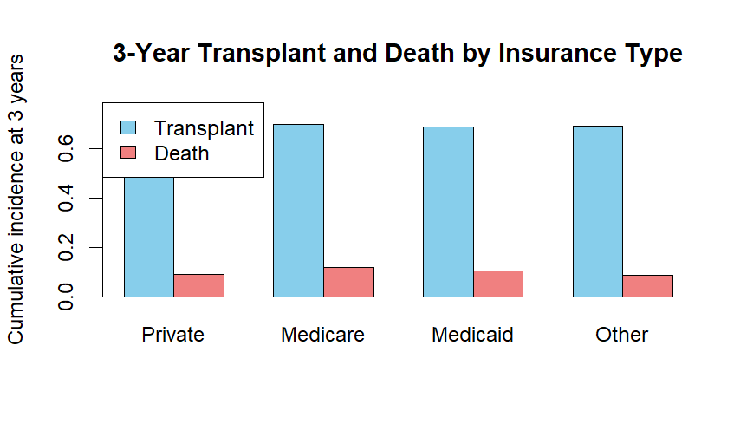
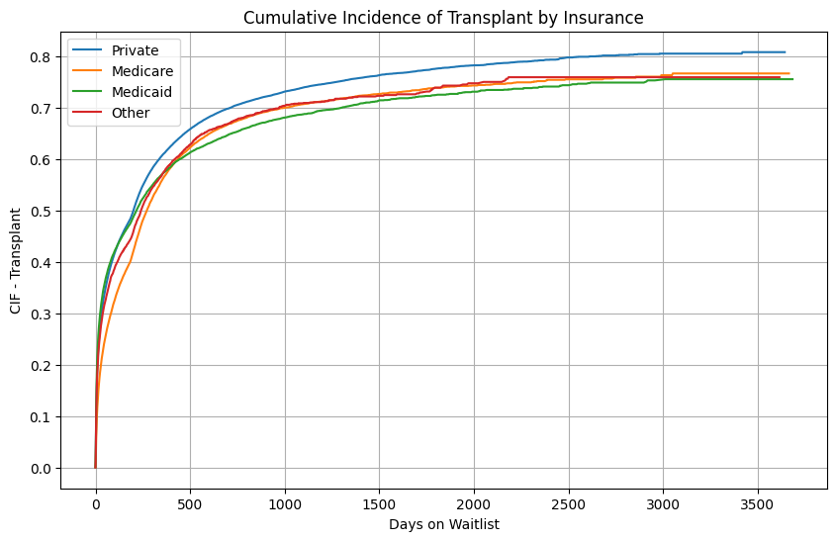
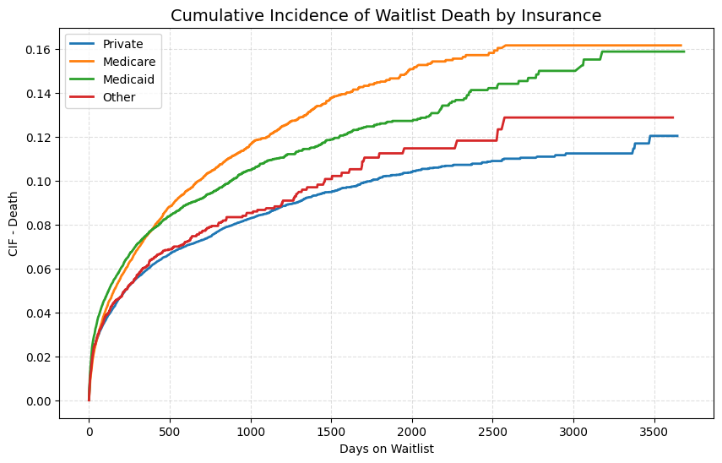


CIF:
Group CIF_3yr_Transplant CIF_3yr_Death
Private Private 0.7376812 0.08477800
Medicare Medicare 0.7037663 0.11906262
Medicaid Medicaid 0.6823518 0.10984905
Other Other 0.7020969 0.08300055

